**FOR IMMEDIATE RELEASE CONTACT:** Sydney Goldston

March 18, 2024 Betenbough Homes

806.319.4413

[sydneyg@betenbough.com](mailto:sydneyg@betenbough.com)

**BEST OF LUBBOCK HOME BUILDER TO CELEBRATE GRAND OPENING OF NEW HOME CENTER***Betenbough Homes to host ribbon cutting ceremony in partnership with Lubbock Chamber of Commerce*

**LUBBOCK, TX -** Betenbough Homes, voted Best Home Builder in Lubbock in 2023, will host a ribbon cutting ceremony and grand opening for their newest Lubbock location. This event will take place at the **Northwest Lubbock New Home Center, located at 6402 19th Street, on April 3, 2024 at 11:00 a.m**. All homeowners, city leaders, media, business partners and non-profit organizations are invited to attend.

Established in the summer of 2023, Betenbough Homes' Northwest Lubbock region serves home buyers in both Lubbock ISD and Frenship ISD. Currently, Betenbough Homes builds in four Northwest Lubbock communities: Matador Pointe, Cypress Ranch, Burgamy Park, and Westmont. Homes in these communities range from 1,000 - 2,500 square feet with 2- 4 bedrooms and 2 - 3 bathrooms.

Betenbough Homes’ Northwest Lubbock region will offer the most affordable pricing for new homes in Lubbock, starting under $1,500/month.

“As a homebuilder committed to making homeownership possible, we are thrilled to be opening our third office location in Lubbock,” said Jonathan Raitz, sales manager for Betenbough Homes’ Northwest Lubbock office. “We are eager to serve and provide homes for even more families through our Northwest Lubbock New Home Center.”

At the grand opening and ribbon cutting ceremony, hosted in partnership with the Lubbock Chamber of Commerce, Betenbough Homes will unveil a new layout for their design center which will allow future homeowners to have more control and customization over the interior options in their new homes.

“Betenbough Homes is committed to continuously improving our process for new home buyers,” shared David Zickefoose, general manager for Betenbough Homes’ Northwest Lubbock office. “We are excited to offer a more luxurious, and customizable design experience at the same affordable prices we’re known for.”

During the event, attendees will enjoy iced tea from Curby’s and sweet treats from Simply Decadent Bakery while learning about the unique value the New Home Center will offer home buyers in Lubbock ISD and Frenship ISD.

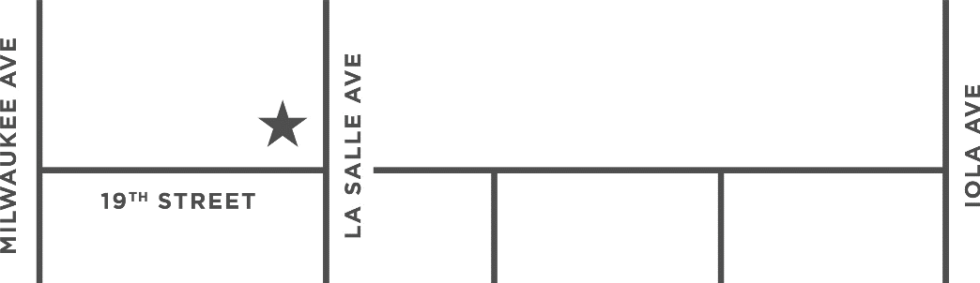**Betenbough Homes –**

**Northwest Lubbock   
New Home Center**

**6402 19th Street  
Lubbock, TX 79407**

Company leadership will be available for interviews following the ceremony. For event details or to learn more about Betenbough Homes, visit betenbough.com.

**About Betenbough Homes**Betenbough Homes, West Texas’ number one new home builder, was founded in 1992 when father and son Ron and Rick Betenbough teamed up to deliver quality new homes at the most competitive price. Based in Lubbock, Texas, Betenbough Homes has built over 17,000 homes in communities across West Texas and is committed to providing more home for less money. Betenbough Homes is an employee-owned company committed to build, serve, and impact the communities it calls home. Ranked among the Top 100 Builders in the nation by Builder magazine, the company consistently receives superior marks for customer service by GuildQuality, a third-party surveying company.

Betenbough Homes currently builds homes in Amarillo, Texas; Lubbock, Texas; Midland, Texas; and Odessa, Texas, with more than three families moving into a brand-new Betenbough home every day. Visit **betenbough.com** for more information on Betenbough Homes.

###